Mrs. Boyce’s Language Arts Review ©2019
SOL Study Guide
Literature Genres
Autobiography  A story of  someone’s life  written by  himself or  herself | Biography  The story of  someone’s life  written by  someone else | Fable  A very short  tale that  teaches  a lesson  or moral;  animal  characters
Fairy Tale  A story passed  orally, that  usually has  magic and  creatures | Legend  Gives colorful  explanations  for events | Myth  A story  handed  down from  earlier times;  some tell  about gods  and goddesses
Nonfiction  Gives  information  about real  people,  places, and  events | Fiction  Imaginative  literature  created by  an author | Folktale  Short story that  gives colorful  explanations  for natural  events

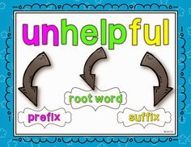
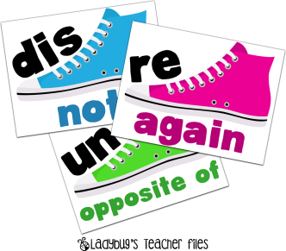
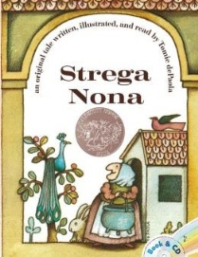
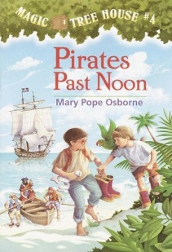
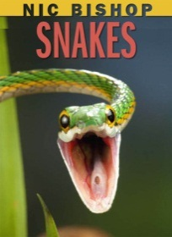
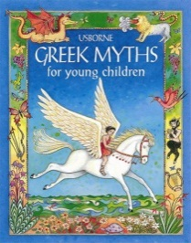
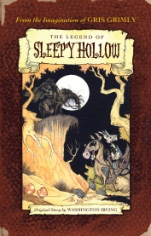
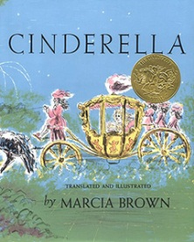
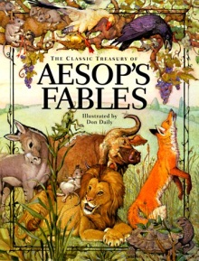
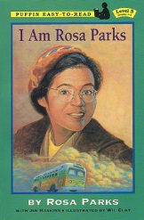
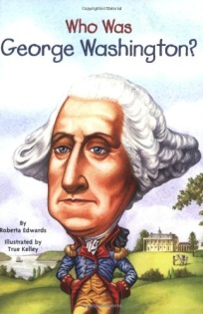
Root word: part of a word that contains
meaning (also called “base word”)
Prefix: a group of letters added to the front of
the word to change the word’s meaning
Suffix: a group of letters added to the end of
the word to change the word’s meaning

POETRY TERMS:
Stanzas:
a section of a poem consisting
of a group of lines that form a pattern that is repeated
throughout the poem
Rhyme:
words ending with the same sound
blame – same –frame
neigh – hay – play
Line or Verse:
a group of words or
sentences that form one section in a poem
Mrs. Boyce’s Language Arts Review ©2019
SOL Study Guide
Author’s Purpose
Why an author writes a text
Persuade: to convince the reader to do something or believe in something
Inform: to give information (textbooks, articles, directions, instructions)
Entertain: a fun story for personal enjoyment

Strategies for
Comprehension Skills:
Using the Three Little Pigs
Compare and Contrast – how different settings, characters, and events are alike and how they are different
The three little pigs are alike in that they are all building
their own home. The three little pigs are different because they choose different building materials and some prefer to play than to work.
Context – the words, sentences, or pictures that surround an unfamiliar word
Drawing a Conclusion – to reach a decision based on evidence in the text
Because the third pig took his time and patiently built a
home out of bricks, I think the house will withstand the huffs and puffs of the big, bad wolf.
Evidence – factual details from the text
Inference – a guess based on evidence
I think that the wolf may try to destroy all the pig’s homes
after he is successful at destroying the house of straw.
Sequence of Events – the order in which things happen in
the story
1) The first little pig builds a house out of straw.
2) Then the second little pig builds a house out of sticks.
3) Finally the third little pig builds a house out of bricks.
Summary (Summarize) – gives only the most important
details in a story
A wolf looking for food finds three pigs, each one having their own home made of straw, sticks and bricks. The wolf threatens to blow their houses down and is successful at destroying the house of straw and sticks. The wolf is not able to blow the third, brick house down and the pigs live to see another day.

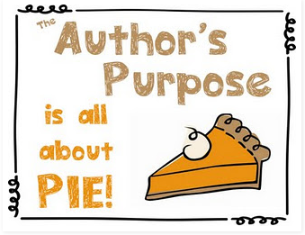
\
Word-Skills
Antonyms: words with opposite meaning
Homophone: one of 2 or more words pronounced alike, but spelled differently and having different meanings
Syllable: a sound made by one or more letters in word; must contain a vowel sound
Synonyms: words with the same meaning

Mrs. Boyce’s Language Arts Review ©2019
SOL Study Guide
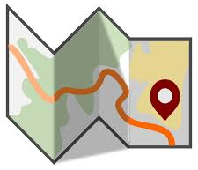
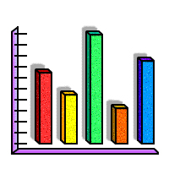
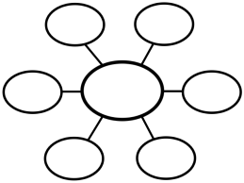
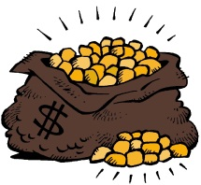
CONTEXT clues

Context Clues are hints that an author gives to help define a difficult or unusual word.

- Definition: The marsh, that wet and muggy place, was home to many alligators and snakes.
- Antonym: She knew the cup wasn’t fragile when she felt its sturdy hand and thick sides.
- Example: A device, such as a phone or mp3 player, can be expensive.
- Synonym: The fox raced swiftly through the trees, quickly running out of sight.

Fictional Literary Elements
Narrator – person, animal or thing that is telling the story from their perspective
Character – any person, animal, or thing in the story
Dialogue – consists of words the characters say to one another; these words are shown with quotation marks
Events – what happens to the characters
Illustration – a picture that shows what is happening in the story
Plot – the overall plan for the story
Setting – where and when a story takes place

Glossary
A list of words used in a book and their definitions

Celsius – a scale on a thermometer where the interval between the boiling point and the freezing point is divided into 100 degrees
Charged Particle – electrons, protons, ions
Corona – the very hot, outermost layer of the star’s atmosphere

Pictures, Illustrations, and Captions:

A photograph of a An illustration of
bar of gold a bag of gold
Graphic Organizers
Tables, Charts, and Maps show
information in a visual way

Table of Contents
Topics/Chapters in the front of a book

Frog’s Diet.....................3
Frog’s Habitat.…………5
Frog’s Physical Traits…..7
Other Information……..8

Bold Print
Highlighted text
Italic print

Heading: divides sections of a book or text and often explains what the section is about
Title: what the text is about

Index
An alphabetical list of topics in the book and their page numbers
Bees……. 7, 12, 15
Butterflies……3, 7
Flies……. 15, 19

Non-Fiction Text Features

Mrs. Boyce’s Language Arts Review ©2019
SOL Study Guide
Reference Resources

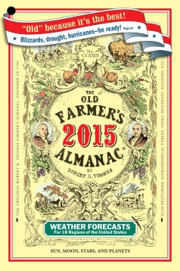  Almanac  A book of facts and  statistics about many  subjects; published  each year | 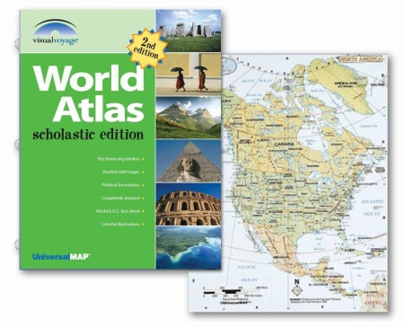  Atlas  Book of maps
Dictionary  A book that lists all the words of a language in alphabetical order; gives a word’s meaning, origin, and part of speech  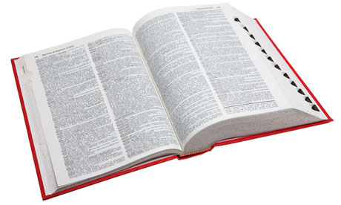  Guide Words: words at the top of the page in the dictionary that tell what words are on that page | 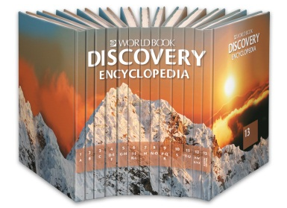  Encyclopedia  A set of reference  books that  contains  many different  subjects; in ABC  order and in  volumes
Internet/Webpages
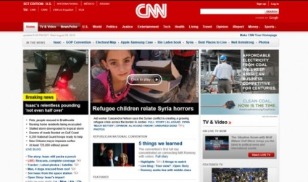
An electronic communication network
Media  Video and audio copies  of television or radio  broadcasts, newspapers,  magazines, etc. | 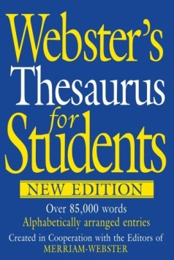  Thesaurus  A book that  lists synonyms  (and sometimes  antonyms)  in alphabetical  order

