**Mrs. Boyce’s Math Review ©2016**

Math SOL Review Card

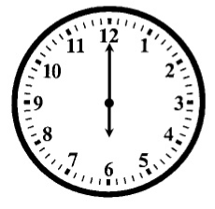

TEMPERATURE  
  
 **Fahrenheit:**US customary measurement

**Celsius:**metric measurement

TIME AND CALENDAR

1 hour = 60 minutes

1 day = 24 hours

1 week = 7 days

1 month = about 30 days  
1 year = 365 ¼ days

1 year = 12 months

**<** = less than

**>** = greater than

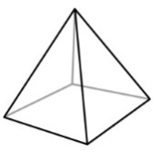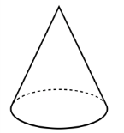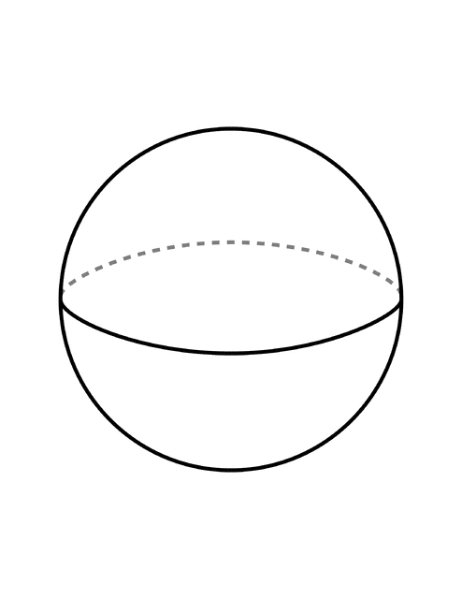

**Hour Hand** – the shorter hand tells the hours

**Minute Hand** – the longer hand tells the minutes

Rounding Rules

1. Find and underline the place you are rounding to

2. Look at the digit to the right and circle the neighbor

3. If the neighbor is 4 or less, then the underlined digit stays the same

4. If the neighbor is 5 or more, then the underlined digit increases by 1

5. All other numbers in front of the underlined digit stay the same. All numbers after the underlined digit turn to zero

**Example:** Round 4,590 to the   
 nearest hundred

**4,590 🡪 4,600**

The 9 (neighbor) tells the 5 to add 1 more.

PLACE VALUE

**______ ______ ______** , **______ ______ ______**

Hundred Ten Thousands Hundreds Tens Ones  
Thousands Thousands

Standard Form – 902, 583

Word Form – nine hundred two thousand, five hundred eighty-three

Expanded Form – 900,000 + 2,000 + 500 + 80 + 3

Place – The location of the number in the place value chart **(hundreds)**

Value – How much a number is worth in a certain place **(500)**

**Congruent:** Figures that are the same size and the same shape

**Similar:** Figures that are the same shape, but not the same size

**Symmetrical:** Exactly the same on both sides of a dividing line

Three Dimensional Figures

|  |  |
| --- | --- |
| **Sphere**  0 faces  0 edges  0 vertices | **Square Pyramid**  5 faces  8 edges  5 vertices |
| **Cube**  6 faces  12 edges  8 vertices | **Cone**  1 face  0 edges  0 vertices |
| **Rectangular Prism**  6 faces  12 edges  8 vertices | **Cylinder**  2 faces  0 edges  0 vertices |

Rays   
 Line Segment Angle

Line

**Mrs. Boyce’s Math Review ©2016**

Math SOL Review Card

**Addition & Subtraction Vocabulary**

**Addend** – number that is added to another number

**Commutative Property** – changing the order of the addends does not change the sum

**Difference** – the answer when numbers are subtracted from each other

**Estimate** – find an answer by rounding to the biggest number

**Identity Property –** when the number 0 is added to another number, that number stays the same

**Related Facts** – three numbers that are reordered in 4 number sentences (Fact Families)

**Sum** – the answer when numbers are added to each other

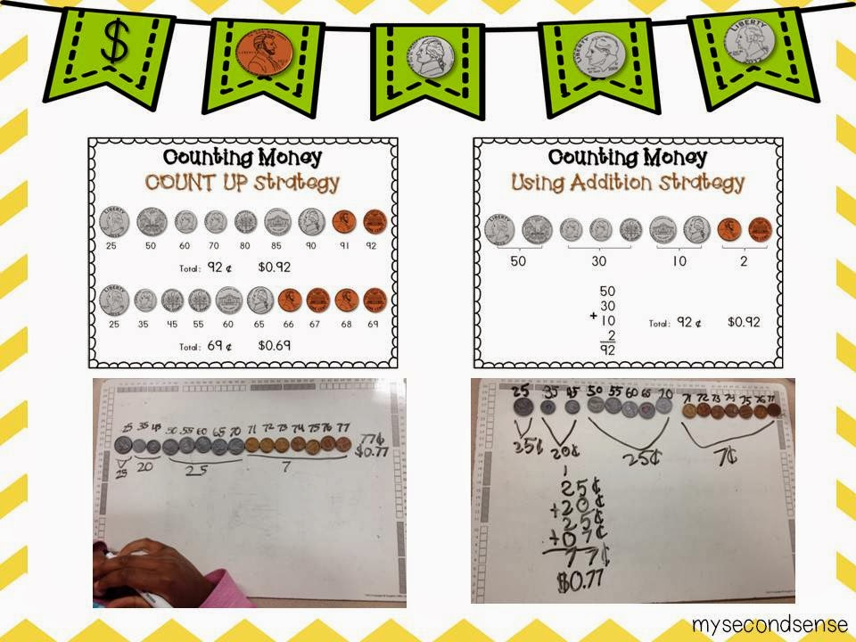

Money

**Strategies for Counting Money:**

1) Start with the coin   
or bill with the highest   
value and keep   
adding coins or bills   
until you get to   
the smallest value.

2) In large amounts of   
change, make groups   
of like coins and add   
together the groups.

Related Facts:

**4 + 3 = 7 3 + 4 = 7**

**7 – 4 = 3 7 – 3 = 4**

Commutative property

Of addition:

**6 + 3 = 3 + 6**

Identity property

Of addition :

**6 + 0 = 6**

ESTIMATION:

456 🡪 500

- 201_ 🡪 - 200_

300

**Mrs. Boyce’s Math Review ©2016**

Math SOL Review Card

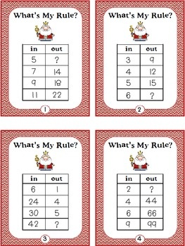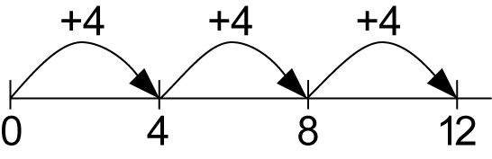

Multiplication Number Lines:  
3 x 4 = 12   
 3 “jumps of 4” = 12

**INPUT/OUTPUT TABLE**

This table shows   
a “multiply by 3”   
rule. When you   
take the input   
number (3) and   
apply the rule   
(3 x 3), you will get   
the output number (9).

+ 1

56

x 2 .   
 112

Related Facts:

**6 x 3 = 18 3 x 6 = 18**

**18 ÷ 6 = 3 18 ÷ 3 = 6**

Commutative property

Of multiplication:

**4 x 3 = 3 x 4**

Identity property

Of multiplication :

**9 x 1 = 9**

2 Digit by 1 digit multiplication

1. Multiply the ones place (6 x 2 = 12).

2. Write the 2 in the ones places and regroup the 1.

3. Multiply the tens of your top number to the ones of   
 your bottom (2 x 5 = 10) then add the regrouped   
 number (10 + 1 = 11).

Key Words for Word Problems

**Addition** – altogether, both, in all, sum, total, together, combined

**Subtraction** – difference, fewer, how many more, how much more, have left, less, remains

**Multiplication** – times, each, product of, each + altogether, each + in all

**Division** – each group has, separated, each + have left, quotient

**Multiplication & Division Vocabulary**

**Commutative Property** – changing the order of the factors does not change the product

**Equivalent** – the same

**Factor**– number that is multiplied with other numbers

**Identity Property –** when the number 1 is multiplied to another number, that number stays the same

**Product** – the answer to a multiplication problem

**Quotient** – the answer to a division problem

**Related Facts** – three numbers that are reordered in 4 number sentences (Fact Families)

**Mrs. Boyce’s Math Review ©2016**

Math SOL Review Card

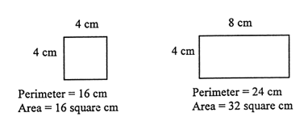

Area and Perimeter

**Perimeter** – distance around a figure (add up all of the sides)

**Area** – number of square units to cover a figure (length x width)

Area = 15 sq. units Perimeter = 18 units

**MEASUREMENT**

1 foot = 12 inches

3 feet = 1 yard

1 yard = 36 inches

2 cups = 1 pint

2 pints = 1 quart

4 quarts = 1 gallon

16 ounces = 1 pound

1 meter = 100 centimeters

1 kg = 1,000 grams

FRACTIONS

**Fractions** – a number representing a part of a whole shape or a part of a whole group

**Numerator** – the top of a fraction; tells how many pieces are shaded, chosen, or being talk about

**Denominator** – the bottom of a fraction; tells how many pieces are in the whole shape or group

**Fraction Number Line:**

**Improper Fraction** – a fraction where the numerator is greater than the denominator

**Mixed Number** – a whole number and a fraction

**Comparing Fractions:**

Use the butterfly trick

**Adding and Subtracting Fractions:**

Add and subtract the number and keep the denominator the same

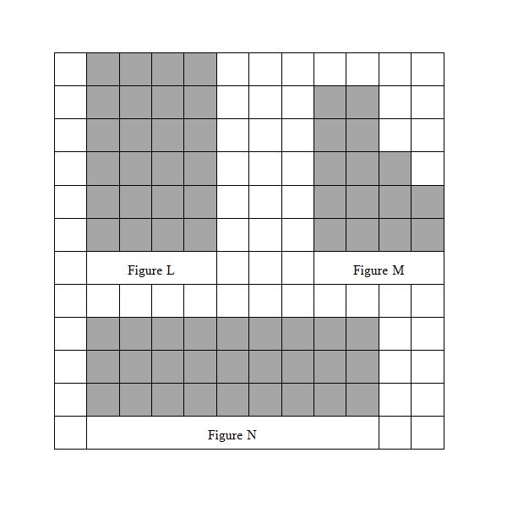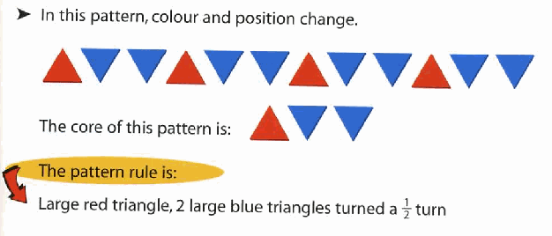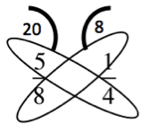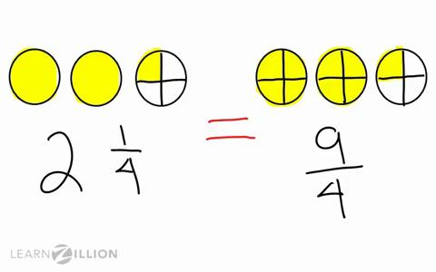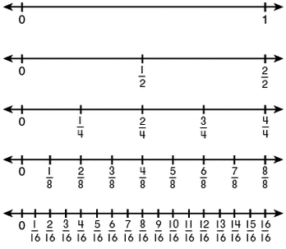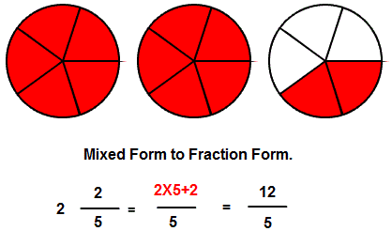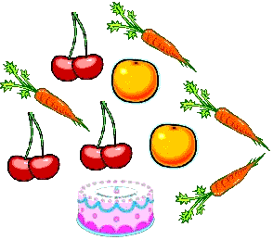

Graphing:

**Bar Graph:** displays and compares data in different categories

**Line Plot:** shows how often something occurs on a number line using x’s

**Picture Graph:** displays data of different categories using pictures

**Key**: tells you how to read a picture graph

Probability:

**Certain:** it will *definitely* happen

**Equally Likely (as likely as):** it could happen as much as another

**Impossible:** it *cannot* happen

**Likely:** there is a greater chance

**Unlikely:** there is a lesser chance

Combinations:

When you find all the possible outcomes of two or more objects.

To find all the outcomes, multiply all the choices together.

Patterns and Functions

**Repeating:** 2, 4, 6, 2, 4, 6, 2, 4, 6…

**Growing:** 2, 4, 6, 8, 10, 12, 14…



+ = - =

>

are vegetables